|  |  |  |
| --- | --- | --- |
| Name: | Brian Petersen - Provo |  |

Wellness is a lifestyle in which your body, mind, and spirit are connected. Ideally, wellness is the optimum state of health and well-being that you are capable of achieving. It alsomeans the personal and community qualities that enable you to rebound from adversity, trauma, tragedy, threats, or other stressors — and to go on with life with a sense of mastery, competence, and hope. Wellness includes positive individual traits, such as optimism and good problem-solving skills. To achieve wellness, five life tasks are important. These include *spirituality*, *self-direction*, *work and leisure*, *friendship*, and *love*. As you focus more on wellness and resilience in your lifestyle, please write down what these life tasks mean to you, successes with the life tasks in the past, or your plan for completing each of these life tasks in the future. As you read the life tasks and domains of wellness, reflect upon and write in the open box how you practice these in your life and what goals you have to maintain wellness and resilience principles in the future.

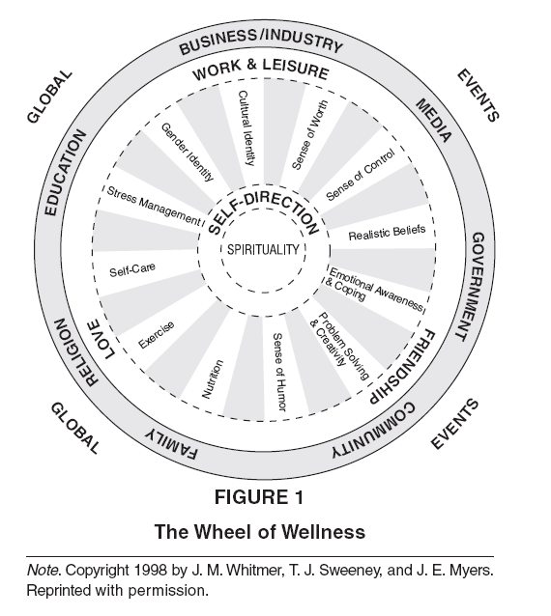

#### Life Task 1: Spirituality

Spirituality is an awareness of being and gives a deep sense of wholeness or connectedness to the universe. Spirituality is not limited to religion or church attendance. Positive thoughts, values, and optimism are components of spirituality; along with a sense of meaning in life. You can measure your level of spirituality by looking at your sense of well-being and experiencing events in a positive manner. Briefly describe your sense of spirituality and goals related to spiritual growth.

|  |
| --- |
| I have a deep connection with spirituality mainly because of my religion and devotion to it. Because of my chosen religion, I understand why I am here on earth and understand that everything happens for a reason. This makes me feel connected with everyone and everything in some way or another. I want to continue to be devoted with some form of religion to provide myself with the spirituality which leads to a healthy life style. |

**Life Task 2: Self-Direction**

Self-direction is the manner in which you regulate, discipline, and direct yourself in daily activities and in pursuit of long-range goals. It refers to a sense of awareness and commitment in meeting the major tasks of life. You can measure your self-direction by reviewing the following 11 items.

*Sense of worth* (Accepting who and what you are, positive qualities along with imperfections; valuing yourself as a unique individual)

|  |
| --- |
| I have a unique set of skills which has greatly contributed me and my family. I feel like this is something of worth thus I have a reason to value myself. I also have recognized my imperfections but I am at ease with knowing these. |

*Sense of control* (Belief that you can usually achieve the goals you set for yourself; having a sense of planning in life; being assertive in expressing your needs)

|  |
| --- |
| I never set unrealistic goals that I know that I will not be able to achieve thus I can usually accomplish those goals that I set. I am generally a person who likes to go with the flow so planning is something that I could work on. I often talk to many people who I may have concerns with, this includes my needs. This allows me to be assertive with my expression of my needs. |

*Realistic beliefs* (Understanding that perfection and being loved by everyone are impossible goals and having the courage to be imperfect; the ability to see things the way they are)

|  |
| --- |
| Both of my parents are really realistic so I have been raised with this mindset. It comes quite naturally to me because of that environment that I have grew up in and now it has become my primary mindset towards most situations. This is an aspect that I do not have to particularly strive for but can keep in check. |

*Emotional awareness and coping* (Being aware of or in touch with your feelings; being able to experience and express your feelings appropriately, both positive and negative; including joy, hope, love, gratitude, anger, fear, loneliness, and guilt)

|  |
| --- |
| I am in tune with my emotions and know how to control them. I am generally realistic and rational and this causes me to hide my emotions even when it acceptable. I need to work on experiencing and expressing my feelings in order to contribute to my overall wellbeing. |

*Problem solving and creativity* (Making a unique place among others in your social interactions; your ability to find new ways of doing things)

|  |
| --- |
| I always enjoy learning new things and taking upon challenges. Because of this, I am constantly practicing my problem solving skills and creativity. I have to find solutions to the problems and that I am learning about but the solutions are also creative and must work for the unique circumstances surrounding those particular problems. |

*Sense of humor* (Being able to laugh at your own mistakes and the unexpected things that happen; the ability to use humor to accomplish even serious tasks)

|  |
| --- |
| I have always been easy going and a sense of humor; it seems as if it has always been a part of my personality. This has greatly influenced my overall wellness and is something that comes very naturally to me. |

*Nutrition* (Eating a nutritionally balanced diet, maintaining a normal weight, and avoiding over-eating and under-eating)

|  |
| --- |
| I do not have the best balanced health diet. I fall into the stereotypical male teenager diet. I plan to be mindful of what I eat that way I can improve this area of my life which will help promote a more balanced wellness. |

*Exercise* (Engaging in sufficient physical activity to keep in good physical condition; maintaining flexibility through stretching and muscle relaxation activities)

|  |
| --- |
| Throughout all my teenage years I have been involved in some form of organized sports activity and I still am today and this is where I have received most of my exercise from. I think it will be easy for me to maintain this area of my life because I have always been doing it. |

*Self-care* (Taking responsibility for your health through physical and dental self-care; practicing safety habits that are preventive in nature; minimizing the harmful effects of pollution in your environment)

|  |
| --- |
| This is an area that I could work on quite a bit. I have a very daring personality and I do not mind taking risks. I should learn to be more cautious and less impulsive that way I will be able to minimize my chances of injuring myself and increase my overall health. |

*Stress management* (General perception of your own self-management or self-regulation; seeing change as an opportunity for growth; ongoing self-monitoring and assessment of your mental and emotional coping resources)

|  |
| --- |
| As mentioned earlier, I have a very going personality and this helps me to manage stress or not to feel any stress at all. When I am under pressure, I feel the need to finish things up but I do not feel the stress that so many others do. Thus managing stress has never been a big issue for me. |

*Gender and sexual identity* (Satisfaction with your gender; feeling supported in your gender; enjoying the masculine or feminine parts of yourself; embracing your sense of sexuality)

|  |
| --- |
| I have accepted my gender and I gladly identify myself as that. I also do not see this aspect of my life changing. I plan to remain with the decisions that I have made in the past for the rest of my life. |

*Cultural identity* (Racial, family, religious, or ethnic traditions; satisfaction with your cultural identity; feeling supported in your cultural identity)

|  |
| --- |
| I feel both right and accepted in the cultural that I have embraced and currently live in. For the most part, everything feels right and correct except for some of the unjust things that occur naturally because of the divisions that a culture creates. I plan to expand my cultural understanding by living in areas in which I may not be quite as comfortable in and by doing so I hope to also learn the cultures of others. |

**Life Task 3: Work and Leisure**

Work (employment or homemaking) and leisure provide an opportunity for pleasurable experiences that are satisfying and provide a sense of accomplishment. They challenge or engage your senses, skills, and interests. Excitement and joy are enhanced while anxiety and boredom are minimized. Write down details of your work and leisure activities.

*Work* (Being satisfied with your work or homemaking; having adequate financial security; feeling that your skills are used appropriately; the ability to cope with workplace or homemaking stress)

|  |
| --- |
| Work has never been an issue for me to find and I have always enjoyed working and feeling as if I am contributing to society or one’s company. I have a high work quality and if something I have made does not meet the standards that I want, I will not release it because it violates those standards that I have set. Since I am a teenager living at home, I have never needed to pay for rent, food, or other basic necessities. I plan to always be employed that way I can enjoy the benefits that come from working and providing quality products and/or service. |

*Leisure* (Activities done in your free time; satisfaction with your leisure activities; having at least one activity in which “I lose myself and time stands still”)

|  |
| --- |
| Over time, my hobbies have changed and become more developed, but I have always had a hobby. I mostly choose hobbies in which I can always continue to learn and have general purpose principles or skills which I can then use in other areas of my life. This is what I feel my free time with and how I make connections with my friends and what I use to make new friends many times. |

**Life Task 4: Friendship**

Friendships enhance self-esteem. The friendship life task incorporates all of your social relationships that involve a connection with others, either individually or in community, but do not have a marital, sexual, or familial commitment. People with satisfying social relationships are more likely to avoid health damaging behaviors, such as smoking, drinking, and not using seat belts, and are more likely to consume a nutritious and healthy diet. Write down details of your plan to enhance friendships in whom you can trust and whom can provide emotional, material, or informational support when needed.

|  |
| --- |
| I have always had a good size group of friends that I have always been able to count on, yet there are some things that could be improved to enhance my current set of friendships. To enhance these friendships, I must make changes that I am directly in control over, my own actions. I plan to be more actively involved in my friend’s lives and to show that I truly do care for their wellbeing and for them as an individual. I want them to understand that I am willing and capable of providing those things that a friendship is supposed to promote. My hope is that by doing this, my friends will naturally provide the same type of positive qualities and it becomes a full circle model. |

**Life Task 5: Love**

The feeling of being loved and valued by others is the core component of social support. For men, women, and children, committed relationships promote better physical and emotional responses to stress. The life task of love necessitates having a family or family-like support system that has the following nine characteristics: shared coping and problem-solving skills; commitment to the family; good communication; encouragement of individuals; expression of appreciation; shared religious/spiritual orientation; social connectedness; clear roles; and shared interests, values, and time. Briefly describe your plan to promote these characteristics of loving family and social support systems.

|  |
| --- |
| My main source of love currently is from my immediate family members. To promote love I plan to take action that is directed at the characteristics involved.  Shared coping – when my parents income decreases, I must decrease my lifestyle.  Problem-solving skills – solve family problems together if that option is available.  Commitment to the family – it is important that I show my family members that they come first; this includes spending time with them rather than with my friends in some cases.  Good communication – constantly be talking to all the members of my family about all aspects of my life.  Encouragement of individuals – give positive feedback to all those in my family and close relatives.  Expression of appreciation – go out of my way to say thank you and to make it known that I really do appreciate all that they do.  Social connectedness – do things with my family that I would not normally do with them currently. Actually form friendships with them rather than have our only connection be by family ties.  Clear roles – perform the roles that are expected of me as a child of the family and not cross the responsibilities of my parents.  Shared interests – find more similar things that both my family and I enjoy that way we can increase our social connectedness. |